

DENTAL CLINIC APPPOINTMENT AND BILLING
SYSTEM

A Research Proposal
Presented to the Faculty of the IT Department
In Partial Fulfillment of
the Requirements in
IT 114: System Integration and Architecture 1
Presented by:
Agato, Kenneth A.
Apas, Christel Grace C.
Ilajas, Ace Rommel N.
Cacayan, Skylar John A.

Presented to:
Janette M. Claro, MIT, LPT
Adviser

Table of Contents | Page
Cover Page | i
Table of Contents | ii
List of Tables | iv
List of Figures | v
II- INTRODUCTION
Background of the Study | 1
Statement of the Problem | 4
Objective of the Study | 5
Significance of the Study | 6
Scope and Limitations | 7
Definition of Terms | 8
II- REVIEW OF RELATED LITERATURE
Related Literature | 10
Related Systems | 12
III- PRESENTATION AND ANALYSIS OF THE EXISTING SYSTEM
The Existing System | 15
Scope | 17
Concept of Operation | 18
IV- FEASIBILITY ANALYSIS
Operational Feasibility | 20
Technical Feasibility | 22
Economic Feasibility (Cost-Benefit Analysis) | 13
Legal and Ethical Feasibility | 24
Organizational Feasibility | 25
V- SYSTEM ARCHITECTURE REVIEW
Adopted Architecture | 27
Architectural Diagram | 29
Conceptual Flow Diagram | 31
VI- SYSTEM INTEGRATION DESIGN
Integration Objectives | 34
Integration Approach | 35
Integration Architecture Diagram | 36
Data Flow Diagrams (DFD) | 37
Integration Implementation | 40
Tools and Platforms | 41
REFERNCES | 43
APPENDICES
Letter to Conduct the Study | 45
Letter to Conduct an Interview | 46
Interview Guide Questions | 47
Patients Survey Questionnaaire | 48
Owner/Staff Survey Questionnaire | 49
Dental Clinic Logbook | 50
Documentation | 51

List of Tables | Page
Table 1. Estimated Costs | 23
Table 2. Expected Benefits | 24
Table 3. Summary Matrix of Feasibility Results | 26

List of Figures
Figure 1. System Architecture Diagram | 30
Figure 2. Conceptual Flow Diagram | 32
Figure 3. Integration Architecture Diagram | 37
Figure 4. Data Flow Diagram | 38

CHAPTER 1
INTRODUCTION

Background of the Study
Dental clinics are essential in maintaining the oral health of communities, providing services that range from routine check-ups to complex dental procedures. However, many clinics, particularly small and privately owned establishments, continue to depend on manual systems to handle critical processes such as patient appointments, billing transactions, and record-keeping. These traditional methods often result in inefficiencies, such as scheduling conflicts, misplaced records, and delays in providing services, which can hinder overall productivity and patient satisfaction. A Computerized Dental Clinic Appointment and Billing System can greatly reduce the manual effort needed to manage appointments, patient records, and billing processes in a dental clinic. With the advancement of technology, dental clinics can now perform their daily operations more efficiently and accurately through computerized systems. Such systems minimize human error, speed up transactions, and ensure that patient data is properly organized and secured.
Traditionally, most dental clinics operate using a manual system, where patient information, appointments, and billing records are written or recorded in logbooks. This practice often leads to misplaced files, scheduling conflicts, and slow service. By using a Computerized Appointment and Billing System, the workflow of dental clinics becomes smoother—from recording patient information, scheduling appointments, generating receipts, and managing financial records—making it more convenient for both staff and patients.
In the modern era, the use of technology in healthcare services has become essential. Based on the Global Payments Journal, many dental clinics globally have shifted to automated systems to enhance efficiency, ensure data security, and offer convenient scheduling to patients. For instance, modern clinics in Japan, Australia, and Singapore now use integrated Dental Management Systems that allow patients to book appointments online, receive automated reminders, and make digital payments. According to Data Bridge Market Research, the adoption of Dental Practice Management Software is particularly important because it streamlines administrative tasks, improves the accuracy and accessibility of patient records, enhances data protection, and optimizes billing and payment workflows. The report further indicates that the growing shift toward digital solutions enables dental clinics to minimize administrative burdens, reduce the risk of manual errors, and deliver more efficient, patient-centered services [1].
In the Philippines, several dental clinics have also begun implementing computerized systems to handle patient appointments and billing. According to Elton et al., (2025), a dental clinic in the Philippines adopted a “Dental Clinic Appointment Management System” that features real-time online appointment booking, automated reminders, centralized patient record management, and a decision-support module to prioritize appointments based on urgency and availability. The clinic’s staff reported that this system effectively resolved common issues associated with manual scheduling — such as appointment conflicts, missed visits, and service delays — thereby streamlining clinical operations and improving the overall patient experience [2].
In Davao Region, several dental institutions and clinics have also begun implementing computerized systems to handle patient appointments and billing. A private dental clinic in Davao City utilizes an online appointment and billing platform that allows patients to schedule consultations, view service costs, and make payments digitally. The clinic’s staff noted that this innovation has reduced paperwork and errors while increasing their capacity to handle more patients efficiently. According to Alejandrino et al., (2023), implementing a computerized dental management system is essential as it reduces manual workload, minimizes errors, accelerates service processing, and enables clinics to accommodate more patients without increasing staff [3].
However, despite the growing use of technology in many cities, Estandarte Dental Clinic in the local area of Compostela, still uses a manual system in handling its daily operations. The clinic records patient details, appointments, and billing transactions using paper-based files, making it difficult to trace records, manage schedules, and monitor balances accurately. The proposed Dental Clinic Appointment and Billing System aims to address these issues by developing a computerized solution that will automate appointment scheduling, store patient data securely, generate billing statements, and produce real-time reports.
The proposed study focuses on improving the existing manual process of Estandarte Dental Clinic, where transactions are still recorded manually. The manual approach causes delays, difficulty in retrieving records, and problems in tracking payments and patient history. A computerized system can automate these processes, providing an organized structure for data storage, quick access to records, and reliable financial tracking. This will lead to improved productivity and a more professional service experience for patients.
Ultimately, this study seeks to help Estandarte Dental Clinic provide faster, more organized, and more accurate service through the integration of technology. The system will serve as a valuable tool for the clinic’s staff to improve efficiency, minimize human error, and ensure a more convenient experience for patients.
Statement of the Problem
The study aims to enhance and automate the existing manual appointment and billing process of Estandarte Dental Clinic, and based on visual observation and interviews conducted with the clinic staff, the following problems have been identified:
- Lack of centralized and secure record management.
Patient information, appointment records, and billing transactions are stored manually in paper-based files, making them vulnerable to loss, damage, or unauthorized access. The absence of a secure digital database also makes data retrieval and record tracking difficult and time-consuming.
- Delay in appointment scheduling and patient servicing.
The manual process of recording and confirming appointments often leads to overlapping schedules, missed bookings, and longer waiting times for patients. The absence of a digital appointment tracker limits the clinic’s ability to manage and monitor patient flow efficiently.
- Errors and Inefficiencies in Billing and Payment Processing.
Billing calculations, receipts, and payment records are currently managed manually, which increases the likelihood of errors, duplication, and inconsistencies. This manual process requires more time and effort from staff, reduces operational efficiency, and can result in inaccurate financial reporting.
- Difficulty in generating real-time reports and summaries.
The manual system hinders the clinic from producing instant reports on appointments, collections, and overall financial status. When statistical or summary data is needed—such as daily appointments, total income, or unpaid balances—the staff must manually compile information from multiple records, causing delays and inefficiency.
Objectives of the Study
This study aims to improve the efficiency and effectiveness of Estandarte Dental Clinic’s operations through a Dental Clinic Appointment and Billing System. The objectives are outlined as a general objective, representing the overall goal of the study, and specific objectives, which detail the key steps necessary to achieve this goal.

General Objectives:
To design, develop, and implement a Dental Clinic Appointment and Billing System that enhances the efficiency of appointment scheduling, automates billing processes, and improves the management of patient records at Estandarte Dental Clinic.
Specific Objectives:
- To develop a digital appointment scheduling module that enables patients and staff to efficiently book, cancel, and reschedule appointments.
- To integrate an automated billing system with a unified database to automatically generate invoices, calculate payments, and securely store centralized patient and financial information.
- To design and implement the core system components, specifically the Appointment Management Module, Billing and Payment Module, and Patient Record Module.
- To evaluate the effectiveness, reliability, and user satisfaction of the developed system among patients and clinic staff at Estandarte Dental Clinic.
Significance of the Study
The proposed Dental Clinic Appointment and Billing System will be beneficial to various stakeholders, particularly within the healthcare and dental management sectors.
- Clinic Administration.
The system will simplify administrative processes by reducing manual workload and minimizing errors in record-keeping and billing. It will also provide a structured way of tracking daily operations and financial reports, improving decision-making and accountability.
- Dental Practitioners.
Dentists will have easier access to patient records and schedules, allowing them to manage consultations efficiently and focus more on patient care rather than administrative tasks.
- Patients.
Patients will benefit from a more organized appointment process, reduced waiting times, and transparent billing transactions. The system also promotes convenience by ensuring that all their information is securely stored and easily retrievable.
- Future Researchers.
This study may serve as a valuable reference for those conducting research related to healthcare automation, digital record systems, and management software development. It provides insights into how technology can be used to enhance operational efficiency in small to medium-sized dental clinics.

Scope and limitations
‎This study focuses on the development of a Dental Clinic Appointment and Billing System for Estandarte Dental Clinic. The system is designed to streamline clinic operations by providing digital appointment scheduling that allows patients to efficiently book, cancel, and reschedule their visits. Additionally, it aims to automate billing processes, including the generation of invoices, calculation of payments, and secure storage of financial transactions.
‎The system also integrates patient information, appointment data, and billing records into a centralized database, improving accessibility, monitoring, and overall management of clinic records. By combining these features, the system seeks to enhance both operational efficiency and the user experience for patients and clinic staff.
‎ However, the study has certain limitations. The system is specifically tailored for Estandarte Dental Clinic and may require modifications for implementation in other clinics. Integration with external systems, such as insurance providers or government health databases, is not included. Furthermore, the evaluation is based on feedback from a limited sample of patients and staff, which may not fully represent all potential users, and system performance may be affected by technical factors such as hardware availability and internet connectivity.
‎
Definition of Terms
Appointment – Refers to the scheduled date and time set by the patient to avail of dental services in the clinic. In this study, it pertains to the electronic booking of dental check-ups and treatments through the system.
Automation – The use of technology to perform tasks with minimal human intervention. In this study, it refers to the automatic handling of appointment scheduling and billing computations.
Billing System – A computerized process used to generate invoices, calculate service fees, and record payments. In this study, it automates the clinic’s billing transactions and financial records.
Database – A structured collection of data that stores information digitally. In this study, it serves as the central storage for patient information, appointments, and billing records.
Data Security – The protection of digital information from unauthorized access, corruption, or loss. In this study, it ensures that patient and financial data are stored and managed safely.
Estandarte Dental Clinic – The local dental clinic that serves as the primary subject of this study, where the proposed appointment and billing system will be implemented and evaluated.
Patient Record – Contains essential information about the patient, such as personal details, dental history, treatment records, and payment transactions.
Real-time Processing – The ability of the system to provide immediate results or updates as soon as data is entered or modified. It ensures instant access to appointment schedules, payment status, and reports .
System – Refers to the developed software solution designed to automate the scheduling, billing, and record management processes of Estandarte Dental Clinic.

CHAPTER 2
REVIEW OF RELATED LITERATURE AND STUDIES
This chapter presents a review of existing studies, articles, and relevant sources related to the development of the Dental Clinic Appointment and Billing System. It highlights previous research, technologies, and systems that serve as a foundation for this study, providing insights into best practices, challenges, and solutions in automating appointment scheduling, billing, and record management in dental clinics.

Related Literature
In today’s digital age, automation has become an essential part of business and healthcare operations. Manual billing and appointment management often lead to issues such as misplaced records, delayed services, and billing inaccuracies. According to Manalo, (2024), the integration of technology in billing systems has allowed organizations to process payments faster, ensure accuracy, and provide better customer experiences [4]. Zoura, (2023) also emphasized that automated billing systems reduce paperwork, promote transparency, and allow real-time tracking of financial transactions [5]. In the context of healthcare, this technological innovation improves patient record management and ensures timely service delivery.
The transition from manual to automated billing systems has been widely discussed in previous literature. Dhumal & Nikam, (2021) explained that using digital billing systems minimizes transaction errors and provides instant data recording. This innovation enhances the accuracy of billing information while ensuring that all records are securely stored in databases for future use [6]. Similarly, Pandey et al., (2024) highlighted that digital billing systems support multiple functions such as invoice generation, payment reminders, and report generation. These integrated systems help administrative staff monitor all financial activities with ease and precision [7].
Moreover, several studies show the importance of system integration between billing and appointment modules. Halde et al., (2025) stated that integrating appointment scheduling with billing allows a smooth flow of patient transactions, reduces redundant entries, and improves the overall efficiency of healthcare facilities [8]. According to Baswaraju et al., (2020), implementing an improved billing system that synchronizes financial and appointment data reduces administrative workload and ensures accurate patient records [9]. This approach also minimizes the risk of overcharging or undercharging patients, which is a common issue in manual systems.
Furthermore, Schwarz, (2025) discussed the increasing reliance on secure databases and data encryption methods in healthcare systems to protect patient and billing information. Data security remains a critical factor when designing an automated billing system because it involves sensitive patient data and financial transactions [10]. Laura & Manager, (2024) also mentioned that with cloud-based storage, organizations can ensure data backup and quick recovery in case of system failure. This feature is especially beneficial for small clinics, such as Estandarte Dental Clinic, that require a reliable yet affordable system to manage both appointments and billing operations [11].
Technological advancements made it possible to develop integrated systems that combine billing, appointment, and patient records in one database. This integration promotes data accuracy, ensures compliance with data privacy laws, and improves reporting and decision-making (Alshameri et al., 2025) [12]. In healthcare settings, adopting digital systems not only saves time but also minimizes record loss, enhances financial monitoring, and provides a reliable way of tracking patient history. A well-designed billing system should allow users to easily encode, update, and retrieve data without technical complexity. In the healthcare setting, accessibility and ease of use are vital because staff members handle multiple tasks simultaneously. Thus, based on the reviewed literature, it is evident that developing a Dental Clinic Appointment and Billing System for Estandarte will greatly enhance efficiency, ensure accurate billing, and improve patient satisfaction.
Related Systems
Several studies have been conducted worldwide to examine the effectiveness of automated billing and appointment systems. In a study by Zhu et al., (2024), the researchers emphasized that the integration of appointment scheduling and billing systems can significantly improve the efficiency of healthcare operations. According to the study, manual processes in dental clinics often lead to delays, misplaced records, and inaccurate billing. Implementing an automated system ensures smoother coordination between administrative staff and patients, allowing faster transactions and better data organization [13].
The International Journal of Electrical and Electronics Engineering discussed the integration of billing systems to automate financial transactions. According to the study, the implementation of billing systems enhances real-time monitoring, reduces human intervention, and prevents billing discrepancies. The researchers concluded that automation can lead to improved efficiency and accuracy in healthcare billing (Lubota, 2024) [14].
According to Nithya et al., (2023), manual billing methods often result in inefficiency and inaccuracies in recording financial transactions. The researchers proposed a digitalized billing platform that automates invoice generation, data entry, and payment recording. The study found that such systems minimize human error, reduce workload, and ensure faster service delivery [15].
A related study by Taslim et al., (2023) revealed that automated billing systems improve accountability and data security. According to the study, traditional billing processes are more vulnerable to fraud and delays, while computerized billing enhances transparency and allows real-time tracking of payments and patient balances [16].
Meanwhile, Anwat et al., (2024) highlighted the advantages of cloud computing in storing patient data and managing online appointments. According to the researchers, a cloud-based system provides flexibility, accessibility, and faster service for both staff and patients. This innovation reduces the workload of dental staff and enhances the overall patient experience [17].
A study by Priyanshu, (2025) emphasized the importance of automated systems in healthcare settings. According to the researcher, integrating billing and appointment systems streamlines data management and eliminates redundancies in patient records. The findings also suggested that automation supports data accuracy, reduces processing time, and improves administrative productivity [18].

CHAPTER 3
PRESENTATION AND ANALYSIS OF THE EXISTING SYSTEM
This chapter presents and analyzes the existing system used by Estandarte Dental Clinic in managing patient appointments, billing, and record keeping. It describes how the current manual process operates, identifies its scope and limitations, and discusses the problems encountered by the clinic. The gathered information serves as the foundation for designing the proposed Dental Clinic Appointment and Billing System.
The Existing System
Estandarte Dental Clinic has been in operation for approximately three years, catering to a growing number of patients in its locality. Despite its continuous service, the clinic still relies on a traditional, paper-based system to manage its daily operations. Appointment scheduling, billing, and record management are all conducted manually, which presents several operational challenges that hinder efficiency and accuracy.
In terms of appointment scheduling, the clinic staff manually record the patient’s information and preferred time in a notebook or on paper whenever a patient books an appointment. According to the staff, “if a patient wants to schedule for the next day or morning, we write it down on paper to mark that the slot is booked.” This system is straightforward but prone to human error. There are instances when multiple patients request the same time slot, resulting in overlapping appointments. The clinic also encounters difficulties when walk-in patients arrive at the same time as those with prior bookings. The staff explained that, in such cases, they follow a first-come, first-served policy, which often causes delays and dissatisfaction among scheduled patients who arrive late. These issues illustrate the limitations of manual documentation in handling dynamic appointment schedules.
When it comes to billing and payment, the process is also done manually. Payments are accepted in cash or through GCash, with receipts issued by hand. While these payment methods are convenient for patients, the lack of an automated billing system leads to slow processing and occasional inconsistencies. There is no centralized tracking system to monitor payments, outstanding balances, or transaction histories, which increases the possibility of miscalculations or misplaced records. The absence of an automated billing module makes it difficult to generate instant receipts, verify payment history, and ensure accuracy in financial reporting.
Patient records are stored in physical folders that are organized alphabetically and kept in filing cabinets. Each record contains essential information such as personal data, treatment history, and payment details. However, over time, this manual filing system has proven inefficient. The clinic staff admitted that some old records have been misplaced or lost, making it difficult to retrieve information when needed. As the clinic continues to serve more patients, the growing volume of paper files becomes harder to manage, leading to longer retrieval times and reduced data security.
Overall, the existing system of Estandarte Dental Clinic is functional but outdated. It relies heavily on manual effort, which is time-consuming and susceptible to errors. The clinic’s growing operations now demand a more reliable, efficient, and modernized approach to managing appointments, billing, and patient records.
Scope
The current manual system of the clinic covers only the basic operational functions, including appointment scheduling, billing transactions, and record keeping. It primarily focuses on in-clinic processes, which means that all transactions are conducted face-to-face. Patients who wish to schedule appointments must personally visit or call the clinic. Similarly, payments are made on-site, and patient records are updated only after each visit.
The system’s scope is limited to handling day-to-day operations without digital integration or automation. Each process—scheduling, billing, and record management—is handled separately, making it difficult for staff to coordinate information. Then a patient pays for a service, the transaction is recorded in a receipt book, but it is not automatically linked to their appointment or treatment history. This disconnection results in redundant tasks and inconsistent data management.
Furthermore, the existing system does not provide any remote access or online functionality. Patients cannot view, schedule, or cancel appointments online, nor can they access their billing or treatment records. The lack of an automated reminder system also contributes to missed appointments, which affects the clinic’s daily operations and service efficiency.
Survey results from patients reinforce these observations. Many respondents expressed dissatisfaction with the current system, citing that it is inconvenient and time-consuming. The majority agreed that overlapping schedules, lost records, and billing errors are recurring problems. They strongly supported the idea of adopting an automated system that would simplify operations, provide real-time access to records, and improve overall service quality. Based on these findings, it is evident that the existing system’s scope is too narrow to meet the demands of both the clinic staff and their patients in a digital age.
Concept of Operations
The current concept of operations at Estandarte Dental Clinic revolves around manual workflow and human intervention at every stage of the process. The system starts when a patient books an appointment, either by visiting the clinic or contacting the staff. The details—such as name, contact number, and desired date and time—are written on paper or in a logbook. On the day of the appointment, patients are attended to based on the recorded schedule, but conflicts arise when multiple patients show up at similar times. Walk-ins are accepted but often disrupt the original schedule, forcing the clinic to adjust appointments in real time.
Once the patient’s treatment is completed, the billing process begins. The staff calculates the total fee manually, accepts payment in cash or via GCash, and issues a handwritten receipt. These transactions are then recorded in a separate ledger, which serves as the clinic’s financial record. However, since the process is not automated, there is no immediate way to verify whether all payments have been properly recorded or matched with patient treatments. This manual billing operation consumes valuable time and increases the likelihood of errors or discrepancies.
The record management process is also paper-based. After each consultation or treatment, the dentist or staff updates the patient’s record by writing the new details on their folder. These records are stored inside a cabinet, and retrieving them during follow-up visits can be tedious, especially when files are misplaced or unorganized. As the clinic accumulates more records over the years, the manual filing system becomes increasingly inefficient.
Survey data from patients further emphasize the shortcomings of this operation. A significant number of respondents indicated that they often experience overlapping schedules and billing confusion, and they find it difficult to reschedule appointments under the current setup. Conversely, most participants strongly agreed that introducing an automated appointment and billing system would make operations faster, more accurate, and more convenient. Many also expressed interest in digital features such as online booking, automated payment receipts, and integration of patient records across services.
Given these insights, the concept of operations clearly shows that the manual system can no longer keep up with the growing demands of the clinic. The proposed Dental Clinic Appointment and Billing System aims to address these operational challenges by integrating scheduling, billing, and record management into a unified digital platform. Through automation, the system will reduce human error, improve time management, enhance data accuracy, and provide a more satisfying experience for both the staff and patients.

CHAPTER 4
FEASIBILITY ANALYSIS
This chapter presents a comprehensive assessment of the proposed Dental Clinic Appointment and Billing System to determine its practicality and effectiveness. It evaluates the system from multiple perspectives, including operational, technical, economic, legal and ethical, and organizational feasibility. The analysis aims to ensure that the system can be successfully implemented, meet the needs of the clinic, and provide tangible benefits to both staff and patients.
Operational Feasibility
Operational feasibility focuses on how effectively the proposed system will function within the clinic’s environment and whether it will improve daily operations compared to the existing manual processes. Currently, Estandarte Dental Clinic relies on handwritten appointment logs, manual billing computation, and physical record storage. This method often leads to scheduling conflicts, misplaced files, and delays in transaction processing.
The proposed system aims to automate appointment scheduling, billing transactions, and record management, thereby improving accuracy, speed, and convenience. It allows patients to book appointments online and receive automated reminders, minimizing scheduling errors and no-shows. For the staff, the system will streamline data entry and retrieval, eliminating the need for manual documentation. It will also enable the dentist to view patient history instantly, which supports better treatment planning.
Survey results from patients indicate strong support for digital transformation, with most respondents agreeing that an automated system would enhance efficiency, accuracy, and overall satisfaction. Staff interviews also revealed a positive attitude toward adopting the new system, as it would reduce workload and improve service quality. Therefore, the proposed system is deemed operationally feasible because it aligns with the clinic’s operational goals and can be smoothly integrated into existing workflows with minimal resistance from users.
Technical Feasibility
Technical feasibility evaluates whether the proposed system can be developed, maintained, and operated using available technology and resources. The system will be developed using modern web-based technologies, which are widely supported and easy to maintain. It requires only basic hardware, such as desktop computers or laptops, and a stable internet connection. The existing equipment at Estandarte Dental Clinic is sufficient to support the proposed system, with minor upgrades possibly needed for performance optimization.
The system will include several modules such as:
- Appointment Scheduling Module – for booking and managing patient appointments online.
- Billing and Payment Module – for processing cash or digital payments and generating automatic receipts.
- Record Management Module – for storing, updating, and retrieving patient data securely.
- Admin Panel – for monitoring overall system activities, generating reports, and managing user accounts.
The development team will use standard programming languages such as HTML, CSS, JavaScript, PHP, and a MySQL database for backend data storage. These technologies are reliable, cost-effective, and compatible with existing clinic systems. Backup mechanisms will be implemented to prevent data loss, and system security features such as user authentication and encrypted transactions will be incorporated.
Economic Feasibility (Cost-Benefit Analysis)
Expense Item | Estimated Cost (PHP)
System Development and Design | ₱25,000
Computer and Network Setup | ₱15,000
Software Tools and Licenses | ₱5,000
Staff Training and Orientation | ₱3,000
Maintenance and Updates (annual) | ₱2,000
Total Estimated Initial Cost | ₱50,000
Economic feasibility determines whether the system’s benefits outweigh its costs. The proposed system requires initial expenses for development, installation, and training, but these costs are minimal compared to the long-term benefits of improved efficiency and accuracy.
Table 1. Estimated Costs

Benefit Description | Estimated Annual Savings/Value (PHP)
Reduced manual workload and documentation | ₱10,000
Improved appointment accuracy and time efficiency | ₱15,000
Faster billing and payment processing | ₱10,000
Reduced paper and printing costs | ₱5,000
Minimized record loss and error correction | ₱5,000
Total Estimated Annual Benefit | ₱45,000

Table 2. Expected Benefits
Based on the analysis, the return on investment (ROI) is achievable within approximately one year after full implementation, as the efficiency gains and reduced operational costs will quickly offset the initial expenses. Thus, the proposed system is economically feasible and offers significant long-term advantages for the clinic.
Legal and Ethical Feasibility
Legal and ethical feasibility ensures that the proposed system complies with existing laws, policies, and ethical standards related to data protection and privacy. The Dental Clinic Appointment and Billing System will store sensitive patient information such as personal details, medical history, and payment records. Therefore, it must adhere to the Data Privacy Act of 2012 (Republic Act No. 10173), which protects individuals’ personal data against unauthorized access and misuse.
The system will incorporate secure login features, encrypted data transmission, and access control mechanisms to ensure that only authorized users (e.g., dentist and staff) can view or modify patient records. Ethical considerations include maintaining patient confidentiality, ensuring data accuracy, and preventing the misuse of digital information. The system will also comply with the clinic’s internal policies on record keeping, professional conduct, and patient communication.
By implementing these safeguards, the proposed system is both legally and ethically feasible, promoting trust between the clinic and its patients while ensuring compliance with national data protection laws.
Organizational Feasibility
Organizational feasibility assesses whether the clinic’s structure, personnel, and culture are ready to adopt and support the new system. Estandarte Dental Clinic is a small yet steadily growing organization that values efficiency and patient satisfaction. The staff and management have shown openness to technological innovation, as reflected in the positive feedback from both the interview and survey results.
The system’s design is user-friendly and requires only minimal training for staff members to operate effectively. It will not replace existing employees but rather assist them in performing their tasks more efficiently. By automating repetitive functions such as appointment scheduling, billing computation, and record retrieval, employees can focus more on patient care and service quality. The management also expressed willingness to invest in technology that can enhance clinic operations.
Therefore, the proposed system is organizationally feasible since it aligns with the clinic’s goals, improves workflow efficiency, and enjoys support from both management and staff.
Table 3. Summary Matrix of Feasibility Results
Feasibility Aspect | Findings | Conclusion
Operational Feasibility | The system streamlines scheduling, billing, and record management, reducing manual workload and improving accuracy. | Feasible
Technical Feasibility | Utilizes readily available web technologies with existing hardware and stable internet connection. | Feasible
Economic Feasibility | Initial cost of ₱50,000 offset by annual benefits of ₱45,000; ROI achievable within one year. | Feasible
Legal and Ethical Feasibility | Complies with Data Privacy Act of 2012; implements encryption, access control, and confidentiality protocols. | Feasible
Organizational Feasibility | Supported by management and staff; user-friendly system requiring minimal training. | Feasible

CHAPTER 5
SYSTEM ARCHITECTURE REVIEW
This chapter discusses the actual development and deployment of the Dental Clinic Appointment and Billing System. It outlines the steps taken to implement the system, including software installation, configuration, and testing. The chapter also highlights how the system is applied in the clinic’s daily operations to ensure efficiency, accuracy, and improved management of appointments and billing processes.
Adopted Architectural
The proposed Dental Clinic Appointment and Billing System adopts a three-tier architecture, which separates the system into three main layers: The proposed Dental Clinic Appointment and Billing System adopts a three-tier architecture, which separates the system into three main layers: the presentation layer, the application layer, and the data layer. This architecture ensures efficiency, scalability, and security.
- Presentation Layer
The presentation layer serves as the user interface of the system. It allows users—such as receptionists, dentists, and cashiers—to interact with the system through a web-based environment. Users can enter patient information, schedule appointments, generate bills, and view reports. This layer collects user inputs and sends them to the application layer for processing, providing an intuitive and accessible interface that simplifies operations without direct interaction with the database.
- Application Layer (Business Logic Layer)
The application layer contains the core logic of the system. It processes inputs from the presentation layer and manages the system’s functions, including appointment scheduling, billing computation, data validation, and report generation. When a receptionist schedules an appointment, the application layer validates the data, checks available time slots, calculates billing amounts, and communicates with the data layer to store or retrieve records. It also handles automated tasks such as sending reminders and updating billing records. This layer ensures that all system operations follow defined rules and that data flows correctly.
- Data Layer
The data layer is responsible for storing all information securely. It contains databases for patient records, appointments, treatments, payments, and staff information. The data layer manages data storage and retrieval as requested by the application layer, ensuring data integrity, security, and accessibility. It also allows the system to generate reports, track patient history, and maintain accurate billing information.
The three layers work together to provide a smooth workflow: the presentation layer collects user input, the application layer processes and validates it, and the data layer stores and retrieves the necessary information. This layered approach promotes efficient operations, ease of maintenance, secure data management, and reliable system performance, making it ideal for small to medium-scale operations such as a dental clinic.
Architectural Diagram
The system architecture of the proposed Dental Clinic Appointment and Billing System is designed to ensure efficiency, reliability, and real-time data processing. It is composed of three major interconnected layers: the client-side interface, the web application server, and the database server. Users such as staff, and administrators access the system through a web browser, where they can perform various actions such as appointments, managing records, and processing payments.
When a user performs an operation, the request is transmitted via HTTPS to the web or application server, which handles all business logic and validation processes. The server then communicates with the database server to store, update, or retrieve relevant data such as patient records, appointment details, and billing transactions. The architecture facilitates real-time synchronization between the client and server, ensuring that every update made by an authorized user is immediately reflected across all modules. Additionally, external integration services such as SMS gateways for reminders and GCash APIs for payment processing enhance the system’s automation and usability.
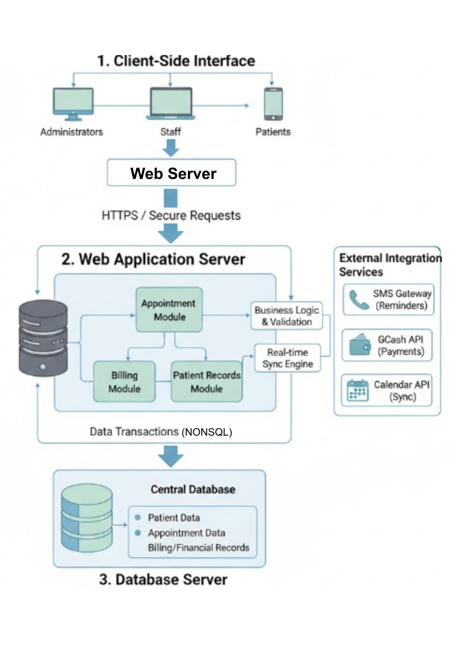
Figure 1. System Architecture Diagram
This figure illustrates the three-tier architecture of the system, consisting of the client-side interface, the web or application server, and the database server. It also shows how users interact with the system through browsers or mobile devices, how requests are processed by the web server, and how data is stored and retrieved from the database. Integration with external services such as SMS gateways and GCash payment APIs is also represented, emphasizing the system’s ability to handle real-time communication and automation.
Conceptual Flow Diagram
The conceptual flow of the proposed Dental Clinic Appointment and Billing System illustrates how data and processes interact among users, the application, and the database. The flow begins when a patient accesses the system through a web or mobile interface to request an appointment. The system validates the entered information, checks the availability of the selected schedule, and records the appointment details in the database. Once confirmed, the patient receives a notification or reminder through SMS or email.
During the patient’s visit, the dentist or staff retrieves the corresponding patient record from the system. After the treatment, the billing process is automatically generated within the same system, where the cashier can compute the total cost and issue a digital receipt. Payments may be processed through cash or integrated online payment methods such as GCash.
All appointment, billing, and record transactions are securely stored in the centralized database, ensuring that information remains consistent and easily retrievable. Authorized users such as administrators or clinic staff can generate reports, monitor appointment statuses, and update patient records as needed. This interconnected flow guarantees that all operations—from scheduling and treatment to billing and reporting—are efficiently managed, well-organized, and accessible in real time.
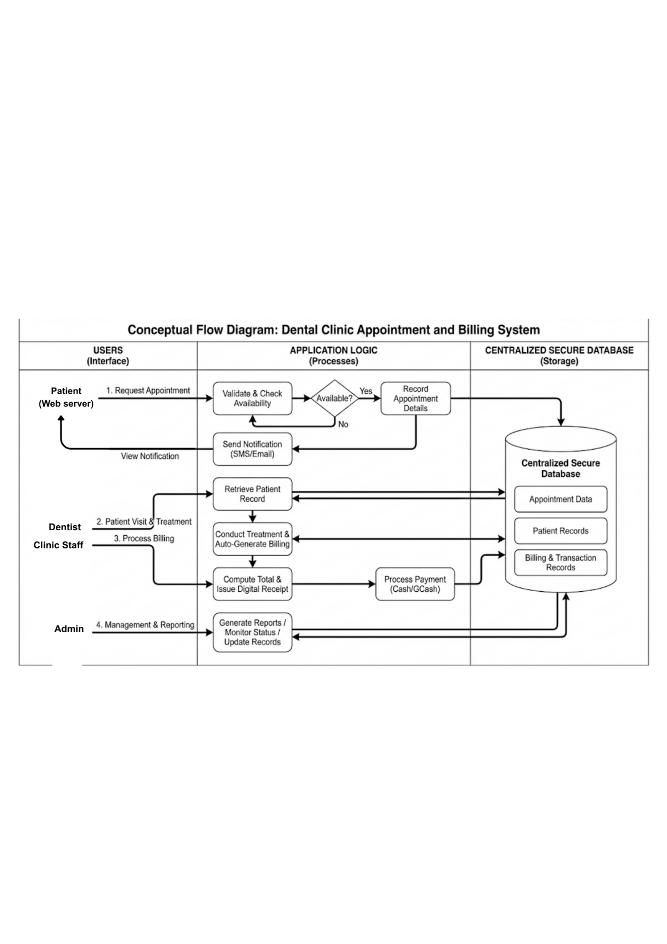Figure 2. Conceptual Flow Diagram
This figure shows the overall workflow of the Dental Clinic Appointment and Billing System. The process begins when a patient arrives at the clinic and the staff checks the dentist’s availability to confirm an appointment. During the visit, the dentist or staff accesses the patient’s record and updates treatment details, which then trigger the billing process. The cashier generates the invoice and processes the payment, while all appointment, treatment, and billing data are stored in the centralized database. Authorized staff and administrators can access these records to monitor schedules, update information, and generate reports, ensuring that all clinic operations remain organized, efficient, and integrated in real time.

CHAPTER 6
SYSTEM INTEGRATION DESIGN
This chapter presents the overall integration plan for the Dental Clinic Appointment and Billing System. It outlines the integration objectives, approach, data flows, architecture, implementation, and tools that ensure the system functions cohesively across different modules—appointment scheduling, billing, and patient records—while supporting secure communication with external services.
Integration Objectives
The integration design aims to ensure that all components of the Dental Clinic Appointment and Billing System operate seamlessly. The primary objectives include:
- To maintain unified, synchronized, and accurate data across all modules. Any update to appointments, billing records, or patient files should reflect instantly throughout the system.
- To enable standardized communication between internal modules (appointment, billing, patient records) and external services such as SMS gateways, online payment APIs (e.g., GCash), and calendar services.
- To ensure immediate processing of transactions such as appointment bookings, payment updates, and record modifications. Notifications should be sent instantly through integrated messaging or email services.
- To enforce encrypted communication and role-based access control during all data transmissions.
- To ensure that appointment scheduling, billing generation, and patient records work as a unified ecosystem without duplication or mismatch of information.
Integration Approach
The system adopts a lightweight, scalable integration design using modern web integration methods:
RESTful API endpoints are used for communication between the frontend and backend server.
- Uses HTTPS for secure transmission
- Supports CRUD operations for patient, appointment, and billing data
- Ensures smooth communication across modules
Webhooks can be used for real-time notifications such as:
- Appointment reminders
- Payment confirmations
- Cancellations or schedule changes
Middleware / API Gateway
A middleware layer handles:

- Input validation
- Authentication (user login, staff access)
- Data formatting
- Routing requests to appropriate modules or external services
This approach ensures the system remains modular, secure, and easy to update.
Integration Architecture Diagram
The Integration Architecture Diagram visually represents how the Dental Clinic Appointment and Billing System connects its core components to ensure smooth and secure operations. It highlights the three-tier structure of the system, starting with the presentation layer where patients, staff, and dentists access the system through a web or mobile browser. Their actions—such as booking appointments, viewing patient records, and processing billing—are transmitted securely to the application server, which handles the system’s business logic and communicates with the middleware or API layer for validation, authentication, and routing. The diagram further shows how the database server manages stored information, including patient data, appointments, and billing records. Additionally, APIs, GCash or other online payment platforms, and optional Google Calendar synchronization, demonstrating how the system extends functionality through reliable third-party communication.
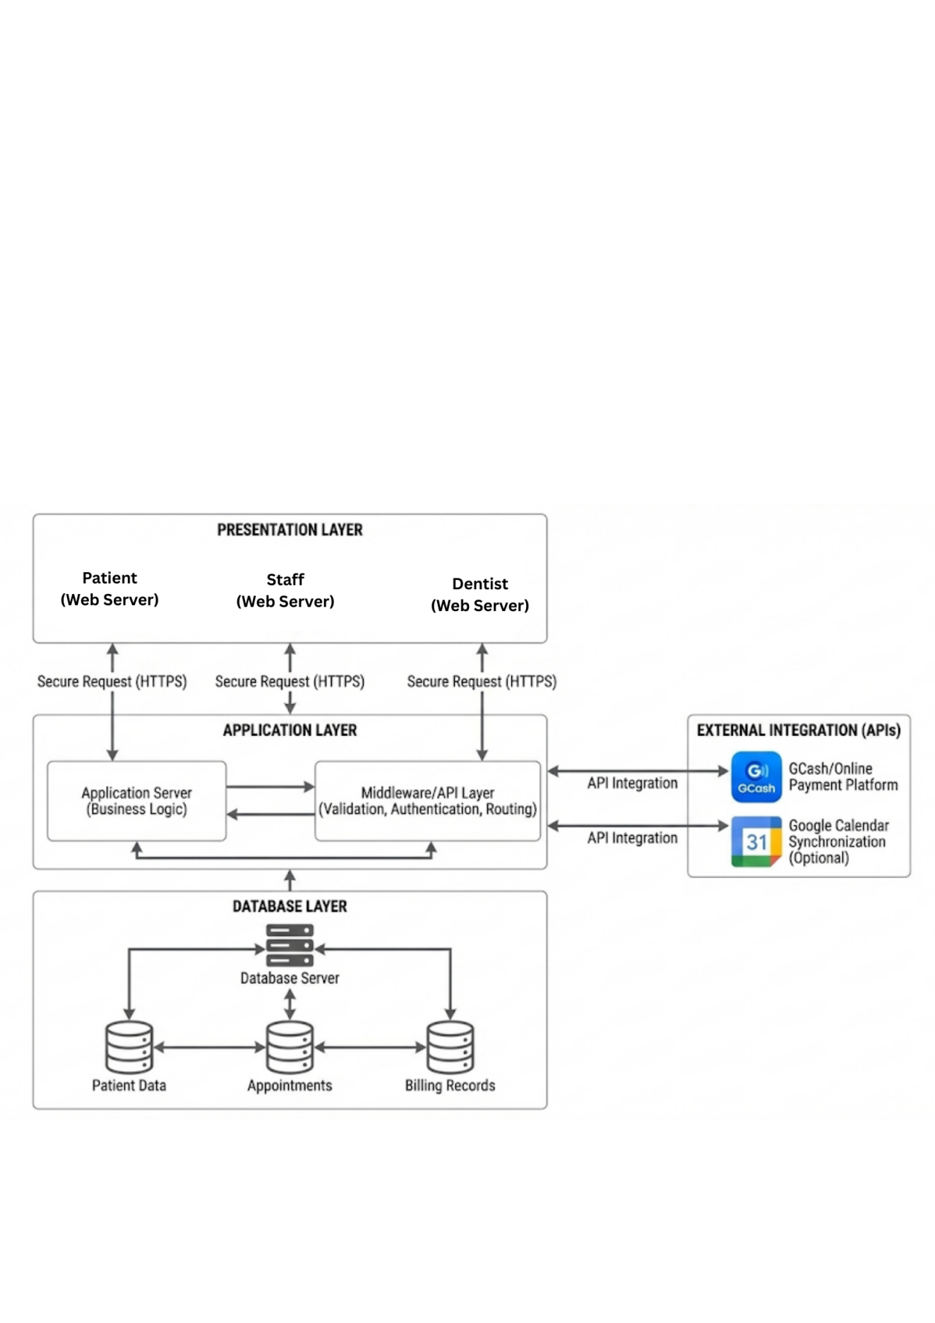Figure 3. Integration Architecture Diagram

Data Flow Diagrams (DFD)
The following Data Flow Diagram (DFD) provides a structured, graphical representation of the information flow within the proposed Dental Clinic Appointment and Billing System. This diagram breaks down the system into its core processes and illustrates how data is initiated by external entities (Patients, Clinic Staff, Dentists) and managed by the system's modules, ensuring accurate record-keeping and efficient operation.
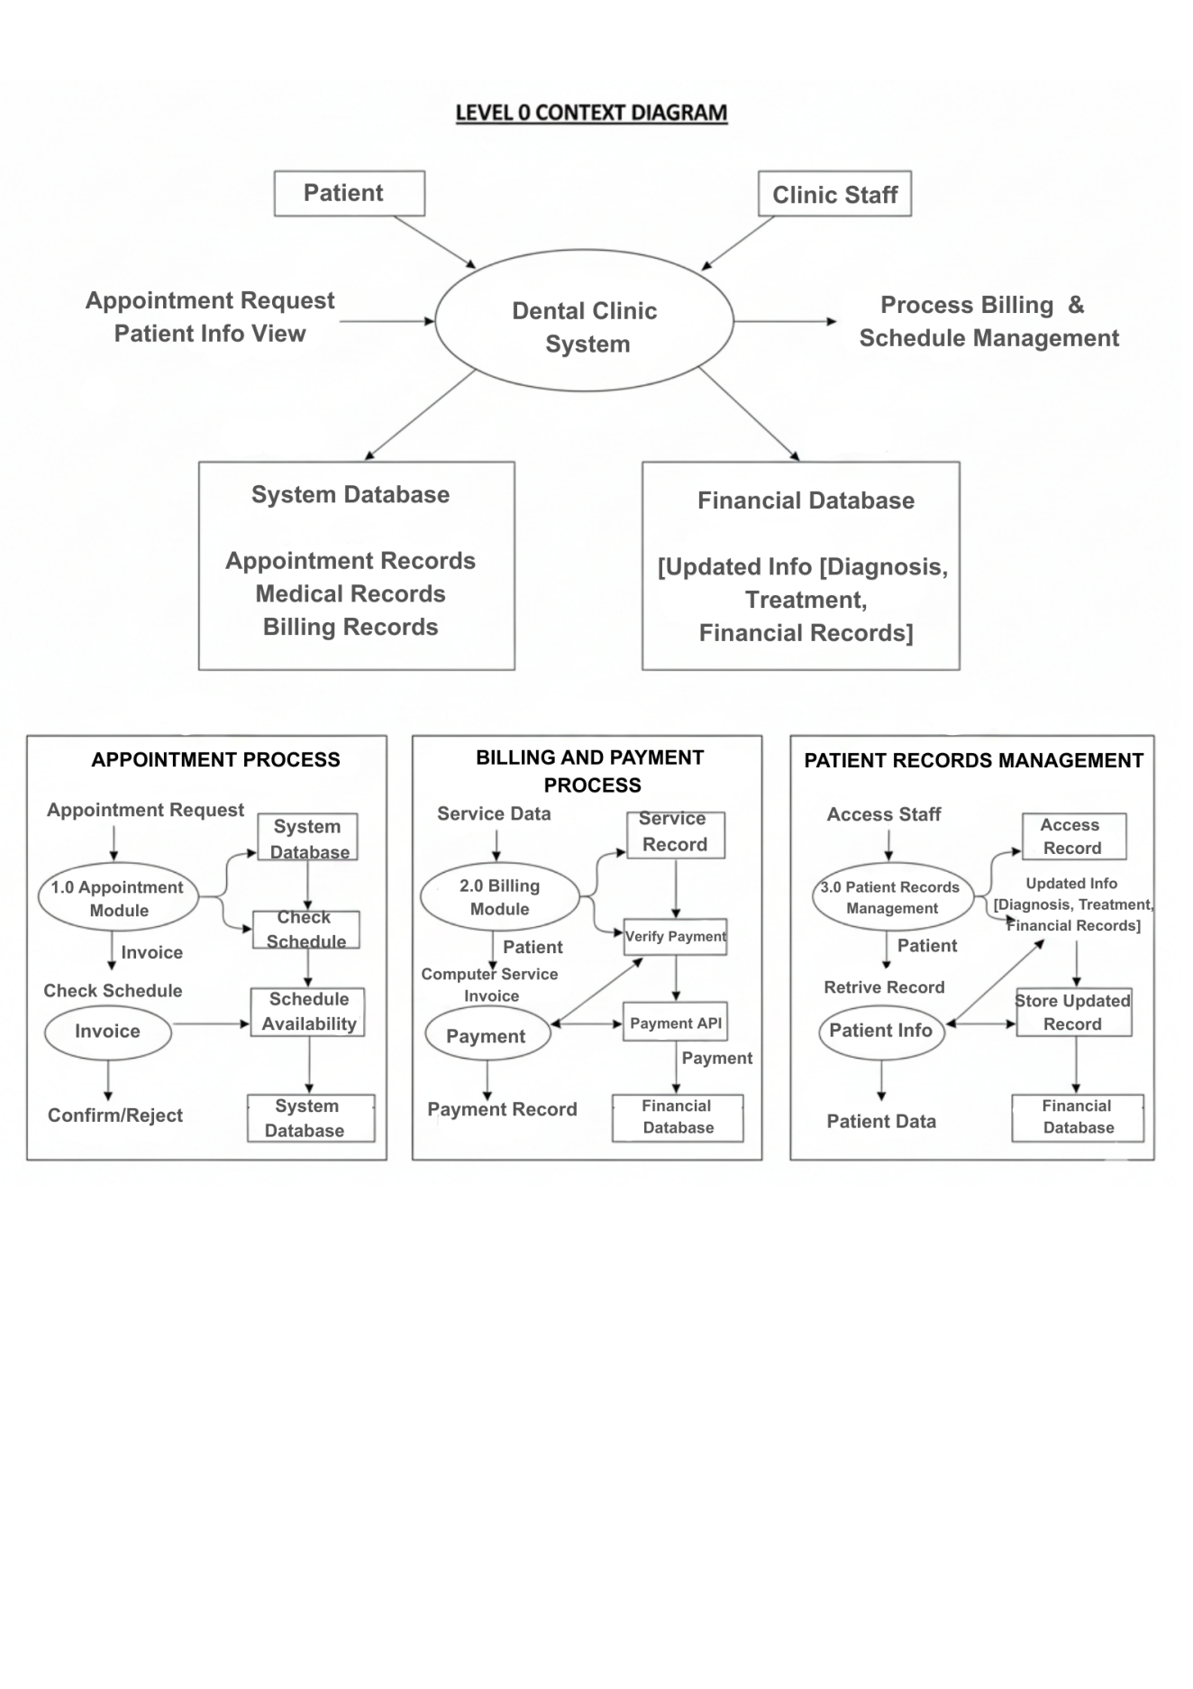Figure 4. Data Flow Diagram

1. DFD Level 0: Context Overview
The Context Diagram (the outermost boundary) shows the entire Dental Clinic Appointment and Billing System as a single process. It illustrates the primary interaction points where Patients, Clinic Staff, and Dentists exchange data with the system. Data flows include appointment requests, billing information, medical records, and reports, establishing the system's scope and its role as the central hub for all clinic data.

2. DFD Level 1: Appointment Process
This flow details how the system handles patient scheduling. The Patient initiates an Appointment Request. The Appointment Module (Process) receives this request, checks the Schedule Data Store for availability, and validates the information. It then saves the confirmed Appointment Record to the data store and relays an Appointment Confirmation back to the Patient. This ensures accuracy and prevents double-booking.

3. DFD Level 1: Billing and Payment Process
This segment illustrates the financial transaction lifecycle. Following treatment, the Clinic Staff inputs Service Details into the Billing Module (Process). This module retrieves Pricing Data from the data store, generates an Invoice, and presents it to the Patient. Once payment is made (which may involve a Payment API for online transactions), the module stores the validated Payment Record in the data store, guaranteeing a reliable transaction history.

4. DFD Level 1: Patient Records Management
This process covers the handling of sensitive patient information. The Dentist or Clinic Staff sends a Record Retrieval Request to the Patient Records Module (Process), which fetches the Patient History from the data store. After consultation or treatment, Updated Patient Data (e.g., diagnosis, treatment plans) is sent back to the module, validated, and securely stored, ensuring that all records are organized, complete, and accessible.
Integration Implementation
The system is designed to integrate internal modules and third-party APIs to ensure smooth and efficient operations across all functionalities. Within the system, the appointment module automatically updates the patient records module with scheduling information, allowing healthcare staff to access real-time appointment details directly from the patient’s profile. The billing module is tightly connected with the appointment module, retrieving treatment information, appointment history, and other relevant details to generate accurate invoices and maintain up-to-date financial records. Any changes in billing, such as payment processing or adjustments, are immediately reflected in the patient’s transaction history, ensuring that all internal data remains consistent, synchronized, and reliable.
The system also connects with external services to enhance usability and operational efficiency. Integration with calendar services enables automatic synchronization of clinic appointments, allowing patients and staff to receive timely notifications and reminders about upcoming schedules. Notification services are incorporated to send confirmations, cancellations, reminders, and billing updates directly to patients via SMS and email, improving communication and reducing missed appointments. Digital payment systems are integrated to allow patients to complete transactions securely online, receive instant payment confirmations, and have their records automatically updated in the billing module.
To maintain the security and privacy of sensitive patient information, the system implements secure token-based authentication, requiring users to validate their credentials before gaining access to any module. This approach protects patient data from unauthorized access and ensures compliance with the Data Privacy Act (RA 10173). The overall integration strategy creates a seamless environment where internal modules communicate efficiently, external services enhance functionality, and sensitive information remains secure, ultimately improving the reliability, accessibility, and overall performance of the system.
Tools and Platforms
The development of the system utilizes a comprehensive set of tools and platforms to ensure efficient coding, collaboration, and deployment, as well as smooth interaction between the front-end, back-end, and database components. Integrated development environments such as Visual Studio Code and PhpStorm are used to provide advanced code editing, debugging, and syntax highlighting features that streamline the development process. Git is employed as the version control system to track changes, manage branches, and maintain a history of updates, while GitHub serves as the remote repository, enabling collaboration among multiple developers and ensuring code integrity throughout the project lifecycle. The system is hosted on web servers including XAMPP and Apache HTTP Server, which provide a reliable environment for testing and deploying the web-based application, efficiently handling HTTP requests and server-side scripts while supporting seamless interaction with the database.
For data management, MySQL is used as the relational database platform, providing secure storage, retrieval, and management of patient records, appointment details, billing transactions, and logs. On the front-end, frameworks and libraries such as CSS, JavaScript, and Bootstrap are incorporated to create a responsive, user-friendly interface compatible with both desktop and mobile browsers. Additional libraries and APIs, including jQuery, Google Calendar API, Gcash API, and SMS/Email notification services, are integrated to enhance interactivity, automate scheduling reminders, and improve communication with patients. The combination of these tools and platforms ensures an organized, collaborative, and maintainable development workflow while supporting a secure, efficient, and fully functional system.

REFERENCES
- D. Bridge, “Asia-Pacific Dental Practice Management Software Market Size, Share and Trends Analysis Report – Industry Overview and Forecast to 2032”,” (2023) https://www.databridgemarketresearch.com/reports/asia-pacific-dental-practice-management-software-market
- E. Ramos, E. Bancud, S. Gumarang, M. Kummer “ Dental Clinic Appointment Management System,” (2025) https://www.thelight-explorer.com/dental-clinic-appointment-management-system/?utm_source=chatgpt.com
- R. Alejandro and F. Pajota, “Implementation of online appointment and billing systems in private dental clinics,” 2023. https://www.warse.org/IJATCSE/static/pdf/file/ijatcse011222023.pdf
- J. Manalo. Automation in healthcare management: Improving efficiency and patient satisfaction 2024. https://www.hashmicro.com/ph/blog/billing-system/?utm_source=chatgpt.com
- K. Zoura, Automated billing system explained 2023. https://www.togai.com/blog/automated-billing-system explained/?utm_source=chatgpt.com
- A. Dhumal and P. Nikam, “Paperless billing in healthcare: QR code and barcode systems,” 2021. https://www.jetir.org/view?paper=JETIR2106786
- R. Pandey, V. Singh, and S. Kumar, “Integrated digital billing and appointment systems in healthcare,” 2024. https://ijsret.com/wp-content/uploads/2024/05/IJSRET_V10_issue3_193.pdf
- S. Halde, P. Sharma, and A. Gupta, “Efficiency improvements through integration of billing and scheduling,” 2025. https://ijrpr.com/uploads/V6ISSUE1/IJRPR38227.pdf
- S. Baswaraju, R. Prasad, and K. Rajan, “Implementation of improved billing system,” 2020. https://www.researchgate.net/publication/345776202_Implementation_of_Improved_Billing_System
- L. Schwarz, “Healthcare data security best practices,” 2025. https://www.netsuite.com/portal/resource/articles/erp/healthcare-data-security.shtml
- M. Laura and T. Manager, “Cloud-based solutions for small healthcare clinics,” 2024. https://www.hashmicro.com/ph/blog/billing-system/
- F. Alshameri, R. Khan, and A. Yousuf, “Integration of digital appointment, billing, and patient records in healthcare,” 2025. https://www.ncbi.nlm.nih.gov/pmc/articles/PMC5425771/
- X. Zhu, H. Li, and J. Wang, “Integrated appointment and billing systems in dental clinics,” 2024. https://www.ncbi.nlm.nih.gov/pmc/articles/PMC11216662/
- International Journal of Electrical and Electronics Engineering, “IoT in healthcare billing systems,” 2024. https://www.internationaljournalssrg.org/IJEEE/2024/Volume11-Issue5/IJEEE-V11I5P125.pdf

- Lubota, “IoT in healthcare billing systems,” 2024. https://www.internationaljournalssrg.org/IJEEE/2024/Volume11-Issue5/IJEEE-V11I5P125.pdf
- R. Nithya, P. Kannan, and A. Singh, “Digitalization of billing platforms in dental clinics,” 2023. https://www.irjmets.com/uploadedfiles/paper/issue_6_june_2023/41679/final/fin_irjmets1686210967.pdf
- M. Taslim, A. Rahman, and S. Khan, “Automation in dental clinic financial management,” 2023. https://www.questjournals.org/jrbm/papers/vol11-issue10/11100105.pdf
- R. Anwat, S. Fatima, and H. Lee, “Cloud-based appointment and billing systems in dental practice,” 2024. https://ijarsct.co.in/Paper17974.pdf
- D. Priyanshu, “Improving data management in healthcare,” 2025. https://www.staple.ai/blog/improving-data-management-in-health
APPENDICES
Appendix A
Letter to Conduct the Study
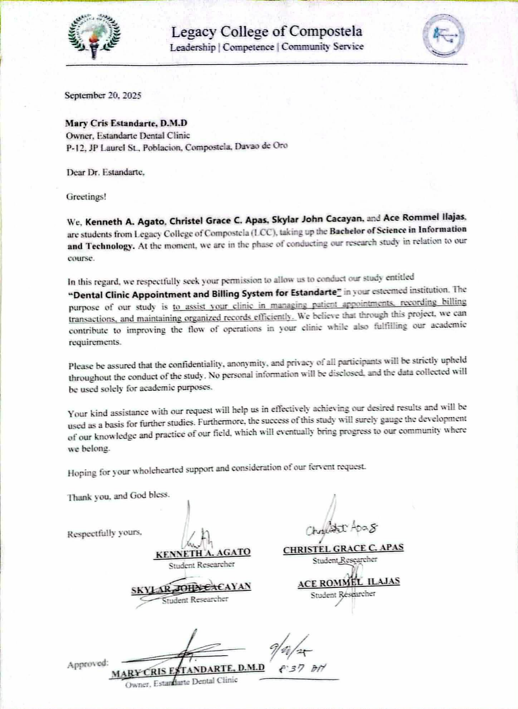
Appendix B
Letter to Conduct Interview
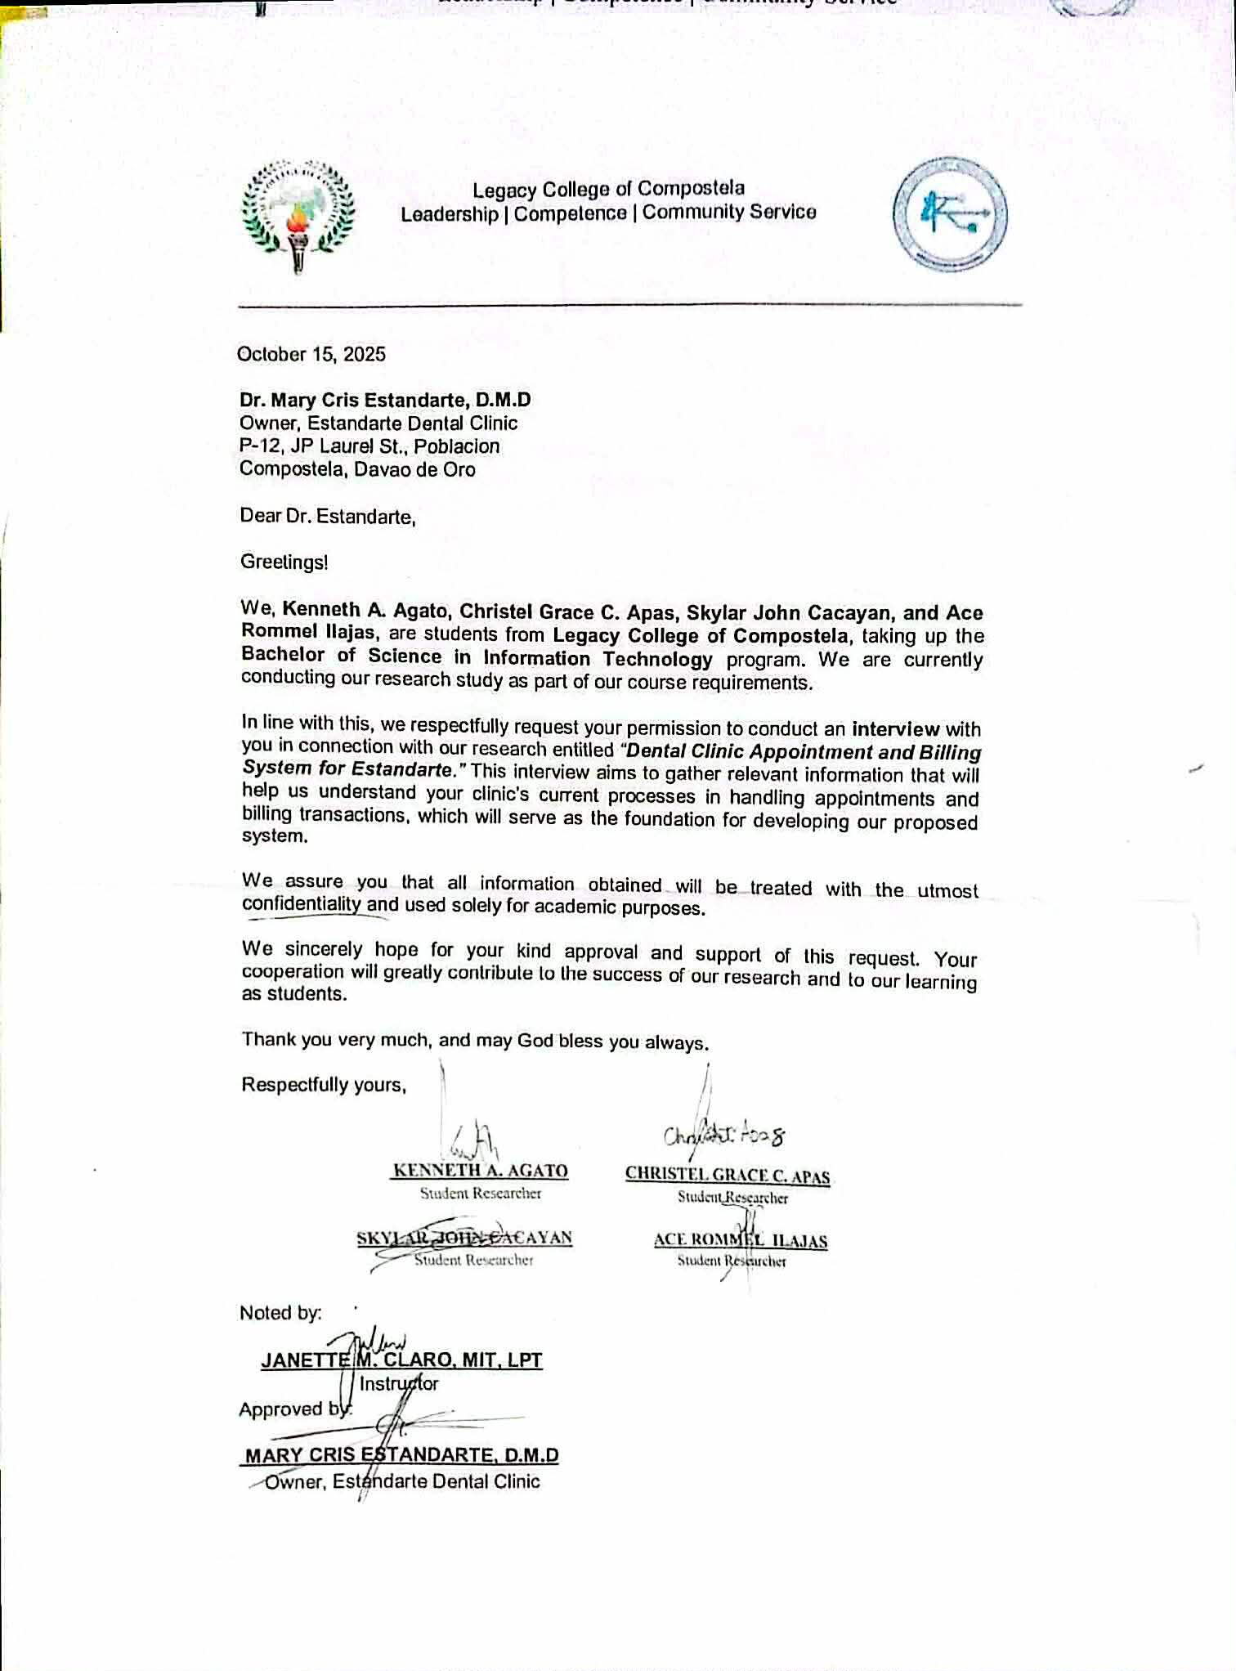

Appendix C
Interview Guide Questions
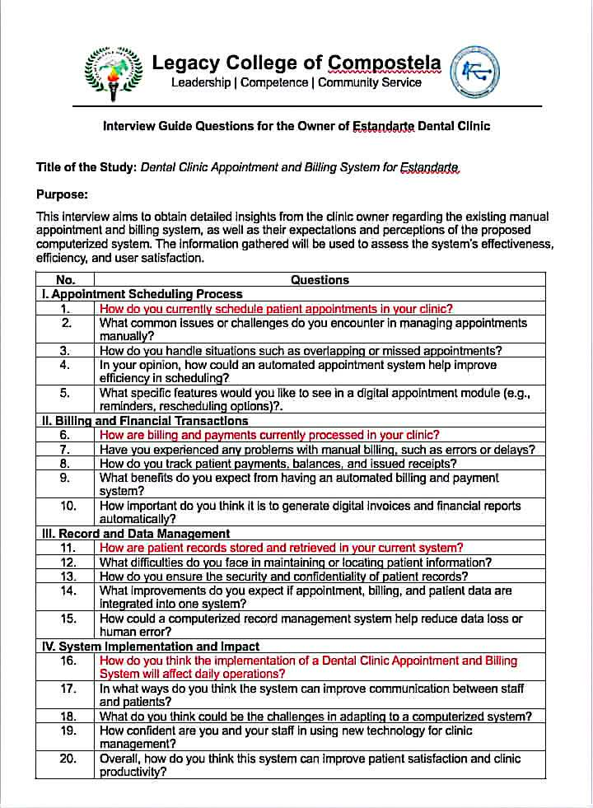

Appendix D
Patient Survey Questionnaire
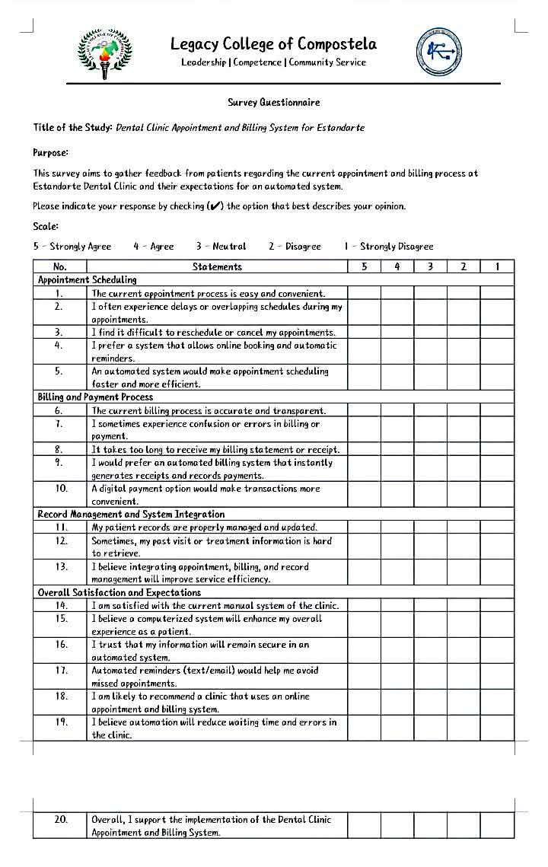
Appendix D
Staff/Owner Survey Questionnaire
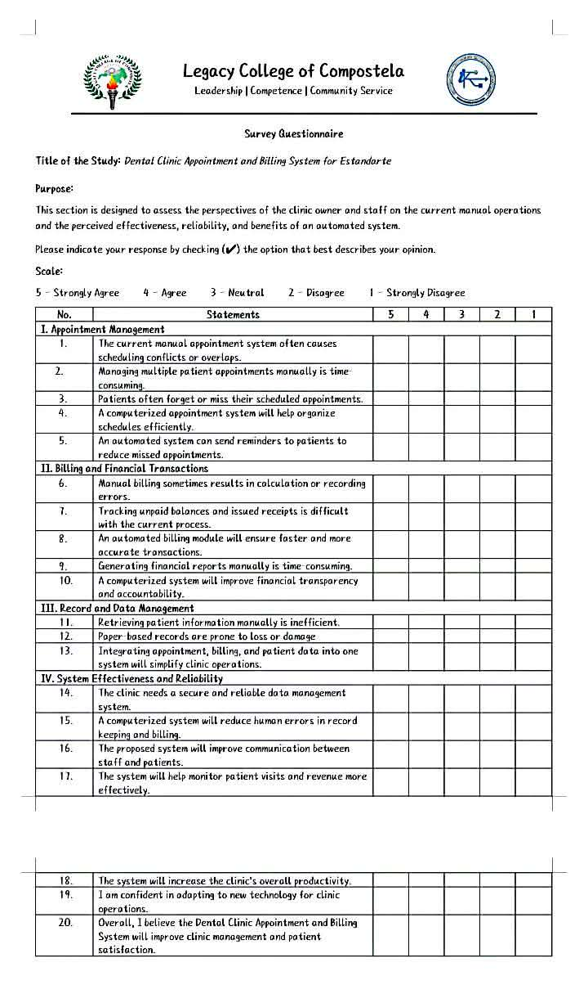
Appendix F
Logbook
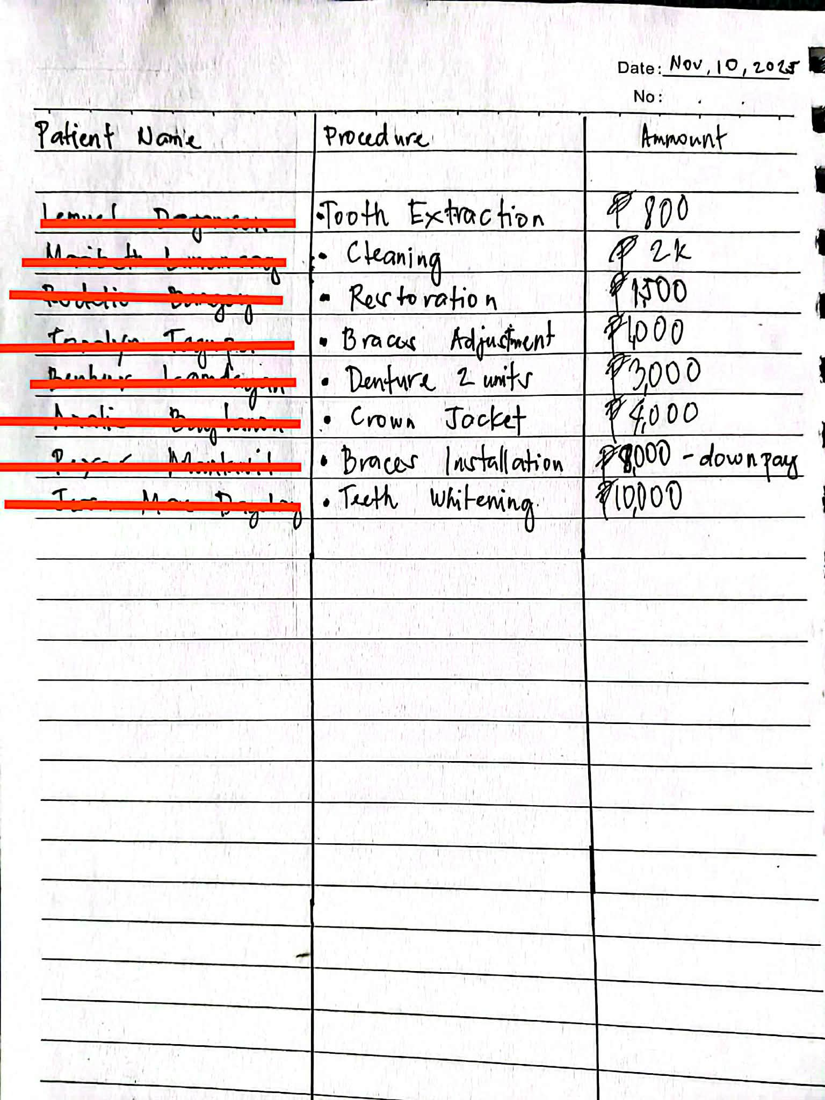

Appendix G
Documentation



